**GENERAL HUMAN BIOLOGY**

**TASK 4 – RESPIRAOTRY & CIRCULATORY SYSTEMS TEST**

***MULTIPLE CHOICE: Circle the most correct answer on the test paper below [24 Marks]***

|  |  |  |  |  |  |  |  |  |  |  |
| --- | --- | --- | --- | --- | --- | --- | --- | --- | --- | --- |
| 1. | A |  | 7. | A |  | 14. | D |  | 21. | C |
| 2. | C |  | 8. | B |  | 15. | C |  | 22. | C |
| 3. | A |  | 9. | C |  | 16. | D |  | 23. | D |
| 4. | C |  | 10. | D |  | 17. | D |  | 24. | B |
| 5. | D |  | 11. | B |  | 18. | D |  |  |  |
| 6. | A |  | 12. | B |  | 19. | D |  |  |  |
|  |  |  | 13. | A |  | 20. | B |  |  |  |
|  |  |  |  |  |  |  |  |  |  |  |

**SHORT ANSWER QUESTIONS 22 MARKS**

1. Label the diagram below. (4.5 marks)

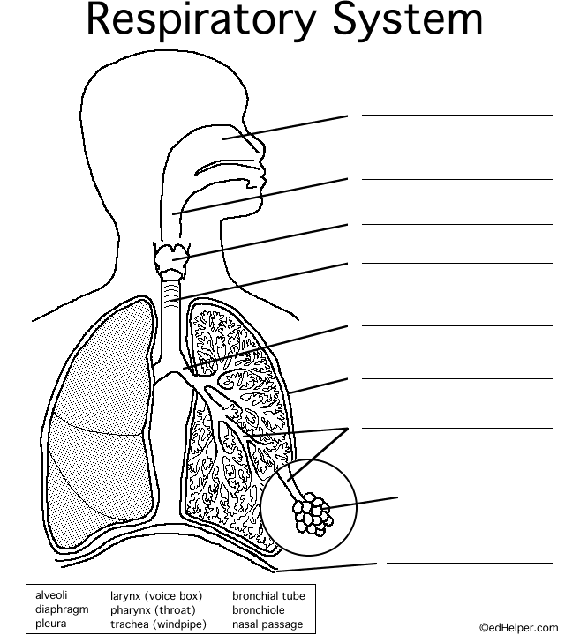

Nasal Cavity

Pharynx

Larynx

Trachea

Bronchi/us

Pleura/ Pleural membrane

Bronchiole

Alveoli

Diaphragm

2. Explain 3 features of alveoli that assist with gas exchange. (3 marks)

*Any 3 of the following:*

- Surface area: Increase the surfaces available for gas exchange (1)

- Moist: Allows gases dissolve into moisture and to diffuse easily (1)

- Thin walls: only 1 cell thick so easily diffuse

- Blood supply: lots of capillaries which allows for lots of blood to exchange with (1)

- Elastic walls: allow increased ventilation and thinner walls during exercise (1)

*If only features given 1 mark*

3. Use the diagram below of the heart to label the key features

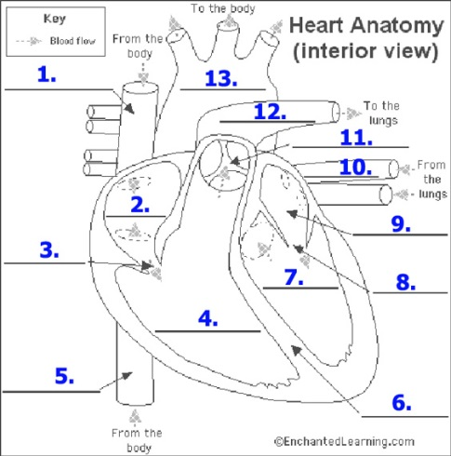

1. Superior Vena Cava 8. Atrioventricular/bicuspid valves

2. Right Atrium 9. Left atrium

3. Atrioventricular/triscupid valve 10. Pulmonary Vein

4. Right Ventricle 11. Semi-lunar valve

5. Inferior Vena Cava 12. Pulmonary artery

6. Septum 13. Aorta

7. Left ventricle (6.5 marks)

4. For each blood vessel listed, describe its features and draw a cross-sectional diagram

|  |  |  |
| --- | --- | --- |
| **Blood vessel** | Features | Drawing |
| Artery | Thick, muscular, elastic  Small Lumen  No valves  High blood pressure  Away from heart | graphic of the structure of vessels |
| Vein | Thin, less muscular, less elastic  Large lumen  Valves present  Lowest blood pressure  To the heart | graphic of the structure of vessels |
| Capillary | One cell thick, no muscle or elastic tissue  Very small lumen  No valves  Low blood pressure  Between arteries and veins | graphic of the structure of vessels |

(6 marks)

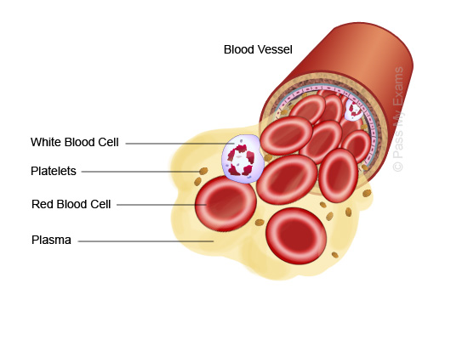5 Label the components of blood on the diagram below

A White blood cell

B Platelet

C Red blood cell

D Plasma

(2 marks)

**EXTENDED ANSWER QUESTIONS 14 MARKS**

6. Describe the function of red blood cells and explain how its shape assists with transport. (4 marks)

- Carry oxygen to cells and remove carbon dioxide from cells. (1)

*Any 3 of the following:*

- Biconcave disc: increases the surface area for gas exchange/diffusion to occur (1)

- No nucleus: more room for oxygen to be carried in RBC / are able to bind to haemoglobin (1)

- Flexible: are able to pass through the small capillaries (1)

- Easily carried: energy use is small only requires anaerobic respiration and effectively distribute oxygen (1)

8. Explain how you would take a person’s blood pressure. (4 marks)

*Any 4 of the following:*

- Using a sphygmomanometer (1)

- Person must be relaxed (1)

- Sitting on a chair, feet flat, arm resting on table (1)

- Cuff placed above elbow, about an inch above joint, not too light/loose about 2 fingers should fit under cuff (1)

- Cords running down top of arm (1)

- Press start, cuff inflates then deflates. Finally values will appear on screen (1)

9. Describe how breathing occurs in the respiratory system. Ensure you include the terms; internal and external intercostal muscles, diaphragm, air pressure.

(6 marks)

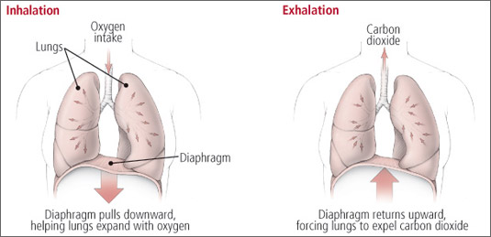

Inspiration

* Diaphragm contracts, moves down. Intercostal muscles contract, moving ribs up and out (1)
* Causes an increase in volume of chest cavity and decreases the pressure in chest cavity (1)
* Air moves from High pressure (outside) to Low pressure (chest cavity) (1)

Expiration

* Diaphragm relaxes, returns to original position. Intercostal muscles relax, moving ribs to original position (1)
* Causes a decrease in volume of chest cavity and increases the pressure in chest cavity (1)
* Air moves from High pressure (chest cavity) to Low pressure (outside) (1)